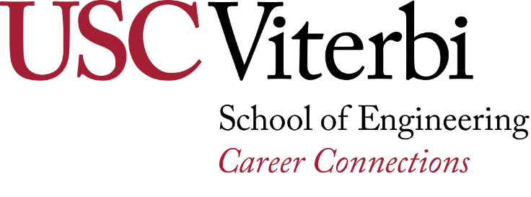
Resume/Cover Letter Assignment
The purpose of this assignment is to help you develop a cover letter to accompany your resume with a well-written and persuasive document conveying your interest with the organization.

Steps:
- Locate an internship or full-time entry-level position related to your major/career interests. You can use Viterbi Career Gateway to find a position.
- Review resume resources and create a draft copy of your cover letter, customized to the research you found on the company/organization.
- Review and update your draft copy including all the relevant information mentioned in the cover letter checklist.
- Bring the Cover Letter Checklist (next page), job posting and any information you found on the company/organization into Ronald Tutor Hall 218 during Drop-In Career Counseling.
- Meet with a Career Adviser to review your documents and obtain a signature (Cover Letter Checklist) from the reviewer.
- Edit and update your cover letter based on the suggestions and information provided by the Career Adviser.
- Turn in your reviewed and signed rough drafts along with the final version of your cover letter by the deadline indicated by your faculty.

Cover Letter 101
A good cover letter identifies information that is not already on your resume and indicates your direct interest with their organization. This document should accompany the resume by specifically demonstrating what skills, interest, abilities or experience that directly connects you to the needs and mission of the organization. Furthermore, the content of a cover letter pinpoints how your unique combination of education and experience will be a valuable asset to the organization. Conduct thorough research on the organization so you can articulate your competitive advantage. Highlight what sets you apart from other candidates and how this difference will ultimately benefit the organization. Remember the goal of this document is to market yourself by selecting the most relevant information about your background to convince them to meet you in-person with an interview. Focus on only one or two concepts to stay simple yet succinct, avoiding a long narrative story of your entire employment history.

Student Engagement & Career Connections – USC Viterbi School of Engineering
https://viterbicareers.usc.edu/
Ronald Tutor Hall 218 • vcareers@usc.edu • 213-740-9677
Cover Letter Checklist
Tips
- Research the company (LinkedIn, Company Website, and Google) and connect how their mission aligns with your own approach or professional interests.
- The document is short and succinct, only conveying one or two concepts that is either unique and or most relevant to why you are interested in their organization.
- Does not repeat the exact same information provided on the resume.
- Avoid sentences that indicate how you would benefit, learn, grow, or use the position as a stepping-stone or temporary position for your other future goals or achievements.
- Focus on how your experience, skill, or interest in the organization will benefit the employer if you are selected.
- Highlight any skills, experience or talent you have, that uniquely enhances you as a standout candidate (What you have that others might not).
- Avoid trying to explain why you do not have a specific skill, instead identify skills you do have that is very similar.
- Minimize “I” statements, repetition of action verbs and excessive redundancy.
- Explain what part of your educational experience is relevant to the position, rather than simply stating what major/degree you are completing.

Cover Letter Format
- Cover Letter has a heading (top contact information) that is identical to the resume
- Includes:
  - Contact name and title
  - Name of company/organization
  - Full mailing address of company/organization
- Document is free from typos and uses proper grammar, punctuation and spelling.
- The document includes three paragraphs and should be approximately 3/4 page in length and no more than one page.

Introduction paragraph
- 3-4 sentences indicating the exact position interested, and any particular information that you uniquely provide to the position (personal brand).
- If a friend, family, or networking contact referred you, mention the person in the first few sentences.
- If applicable, provide a reason why your contact believes you would be a good fit for the organization.

Main Body
- Select information you researched regarding the company’s goals, accomplishments and opportunities to explain how you share the organizations approach or perspective.
- Identify a main ability, skill or experience you have as the reason why you are interested in their organization or position.
- Provide clear details explaining how your qualifications and interests align to benefit the employer using specific examples.
- Identify a specific responsibility from the position description, and explain how your previous position or project will bring expertise knowledge or experience to their organization.
- Organize the sentences according to themes, placing the most relevant concepts first.

Final paragraph
- Provide a final reminder sentence that clearly indicates why the combination of your education, skills and experience is match for the position.
- Mention that you would like to meet and discuss the position further.
- End your letter with confidence (don’t beg) and a way to follow-up for an interview (email and phone number)
- Thank the reader for their time and consideration

Cover Letter Reviewed by:_______________________________ _____________________________ Date ___________
(PRINT NAME) (SIGNATURE)
Student Engagement & Career Connections – USC Viterbi School of Engineering
https://viterbicareers.usc.edu/
Ronald Tutor Hall 218 • vcareers@usc.edu • 213-740-9677

